22 January 2020
His Excellency Mr Andrei Kelin,
Russian Ambassador,
6/7 Kensington Palace Gardens
London W8 4QP

Dear Ambassador,

The Federation of Poles in Great Britain which has represented the Polish community in this country since 1946 wishes to express the anger and dismay of its member organizations, and particularly those representing Second World War veterans, at remarks made before Christmas by President Vladimir Putin concerning the role of Poland at the outbreak of the Second World War and his suggestion that Poland collaborated with Hitler.

While President Putin is right to draw attention to the harmful impact of the Munich Agreement in 1938 in encouraging Hitler to pursue his aggressive policy towards Czechoslovakia, the Polish government and the Polish people played no part in the making of that agreement. Once Germany had decided to break the Agreement and invade Czechoslovakia, the Polish government felt it incumbent to prevent the Germans from taking over the Cieszyn district which had been Polish ethnic territory seized illegally by the Czechoslovak army in 1919. However, Poland can take no responsibility for the betrayal of Czechoslovakia by the Western Powers.

In the meantime, may we remind you that it was Poland that had first wanted to remove Hitler with a joint military operation with France in 1933, although the French government did not support the proposal. At this time a resurging German Army was actually being trained and equipped in Russia. France’s refusal to stop Hitler caused Poland to maintain non-aggression pacts with both Germany and Russia in order to retain a balanced peace in Eastern Europe. Later it sought to protect Russia from invasion by refusing to support Hitler’s plan for a joint invasion of Russia by Germany and Poland.

However, the immediate catalyst for the outbreak of the Second World War was the Molotov-Ribbentrop Pact which encouraged Hitler to invade Poland aware that the secret protocol would cause the Soviet government to assist Germany in a joint invasion of Poland. It is Russia’s cooperation with Hitler, and not Poland’s, that was the final cause for the outbreak of war and Russia must take its share of blame, along with Germany, for the death of more than 6.5 million Polish citizens, both military and civilian, who perished in that war and for the devastation that left Poland in ruins.

May we also remind you that during the Second World War at least 560,000 Polish citizens perished at the hands of the Russian government. These included the 22,000 Polish officers, policemen and other members of the Polish elite who were brutally shot by the NKVD directly on the orders of the Politburo in Katyn, Mednoye, Kharkov and other execution sites. However, these statistics did not include the 111,000 Soviet citizens of Polish ethnic origin executed with equal brutality by the NKVD in the genocide of 1938/1939 which immediately preceded the War. Also, at least 1.2 million Polish citizens were brutally deported in the first two years of the War to Siberia, Kazakhstan and other outlying areas of the Soviet Union and barely half survived. These Russian crimes were coordinated in a common policy with Nazi Germany of destroying Poland’s elite and removing Poland from the map.

We are aware of the great suffering and eventual heroic struggle of the Russian people against Nazi Germany’s invasion after 1941 when 25 million Russians perished. We are aware too of the role of Russian soldiers in pushing the German army out of Polish territory and liberating the German death camps. This common struggle and suffering could have caused Russia and Poland to resist and defeat Nazi Germany together. Instead the Soviet Government chose to introduce a reign of terror in Poland, having earlier betrayed the Polish freedom fighters and the civilian population during the Warsaw Uprising in 1944. With extraordinary cynicism the NKVD kidnapped the 16 leaders of the Polish Underground state, which had resisted the German occupation since 1939, and accused them of being German agents. Soviet Russia imposed a puppet regime on Polish territory and forced Poland to introduce a moribund economic system that only augmented the massive material losses incurred during the War. Poland was only free after Russian troops finally left Poland in 1993.

We are very concerned that President Putin’s comments undermine the improved Polish-Russian relations that had grown during the presidencies of Mikhail Gorbachev and Boris Yeltsin. We fear that President Putin’s latest remarks could be seen as an example of the negative way that Russian government spokesmen and Russian media are reinterpreting Russia’s role in the War. We remember that President Putin has already expressed regret in the past at the abolition of the Soviet Union, even though to all the countries neighbouring Russia the existence of the Soviet Union was seen as a threat to their sovereignty, their culture and their economy.

We hope very much that Russian and Polish relations can improve but we are concerned that such a hostile attitude to Poland’s past could reflect a more hostile attitude to Poland today. We fear that unless such misinterpretations of the past are re-evaluated it will cause the Polish community in the UK to continue to distrust Russia’s present day intentions towards Poland, its neighbours and the United Kingdom.

Yours sincerely,
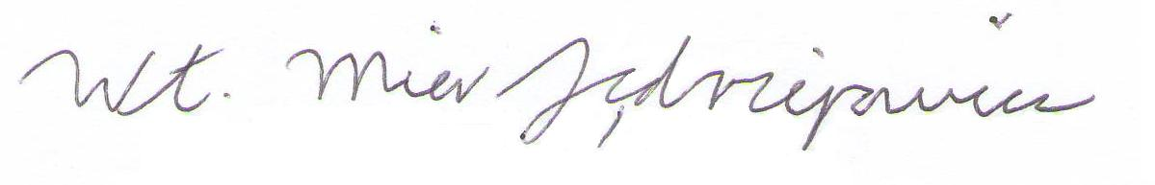
Włodzimierz Mier-Jędrzejowicz, Ph.D.
Acting Chairman
Federation of Poles in Great Britain C.I.O

